

**Placement Empowerment Program**

***Cloud Computing and DevOps Centre***

***Set Up a Load Balancer in the Cloud :*** *Configure a load balancer to distribute traffic across multiple VMs hosting your web application.*

**Name: Bhuvana k Department: CSE**

**Introduction**

In this Proof of Concept (POC), the focus is on setting up a cloud based Load Balancer using AWS to distribute traffic across multiple virtual machines (EC2 instances). Load Balancers play a crucial role in modern cloud architectures by ensuring high availability, fault tolerance, and scalability for web applications. This POC demonstrates the basic setup of an AWS Load Balancer, allowing traffic to be distributed between two EC2 instances running simple web servers.

**Objectives**

1. To understand the process of creating and configuring EC2 instances in AWS.

2. To install and configure a web server (Apache HTTP Server) on Linux-based EC2 instances.

3. To set up an Application Load Balancer to distribute traffic across multiple servers.

4. To validate that the Load Balancer works as intended by testing it with unique responses from each server.

5. To build a foundational understanding of cloud-based load balancing for real-world use cases.

**Overview**

The POC covers the following:

1. Creating EC2 Instances: Setting up two virtual machines (WebServer1 and WebServer2) in the AWS Free Tier.

2. Configuring Web Servers: Installing and configuring Apache HTTP Server on each instance to host simple HTML web pages.

3. Setting Up a Load Balancer: Creating an Application Load Balancer (ALB) to distribute incoming traffic evenly between the two EC2 instances.

4. Testing the Load Balancer: Verifying that the Load Balancer works by checking the DNS name and ensuring it alternates traffic between the two servers.

**Step by Step Overview**

**1. Create an EC2 instances**

- Log into your AWS account.

- Create an 2 EC2 instances “ec2-1” and “ec2-2”. Under Network Settings, click "Edit" and ensure "Allow HTTP traffic from the internet" is checked to enable web traffic.(My name and my bhhu)

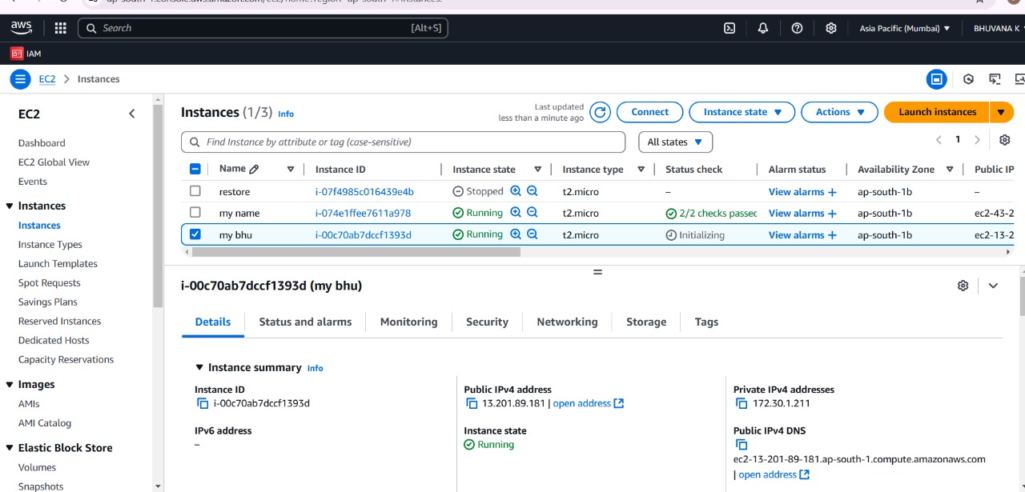

**2. Connect to your instances**

Click on ec2-1, then click Connect. Use the instructions under SSH client to connect to your instance via terminal.

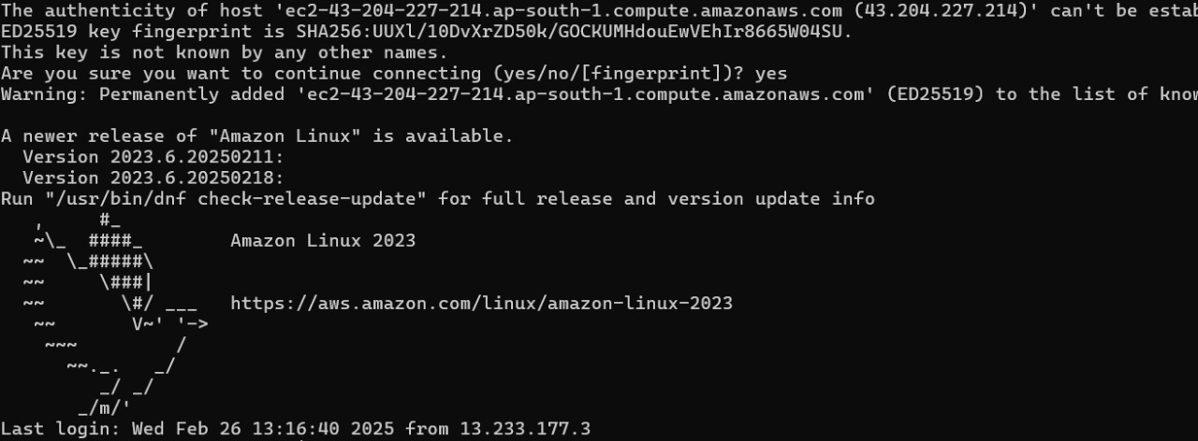

### **3. Running the instance**

Run the following commands to install and start a web server.

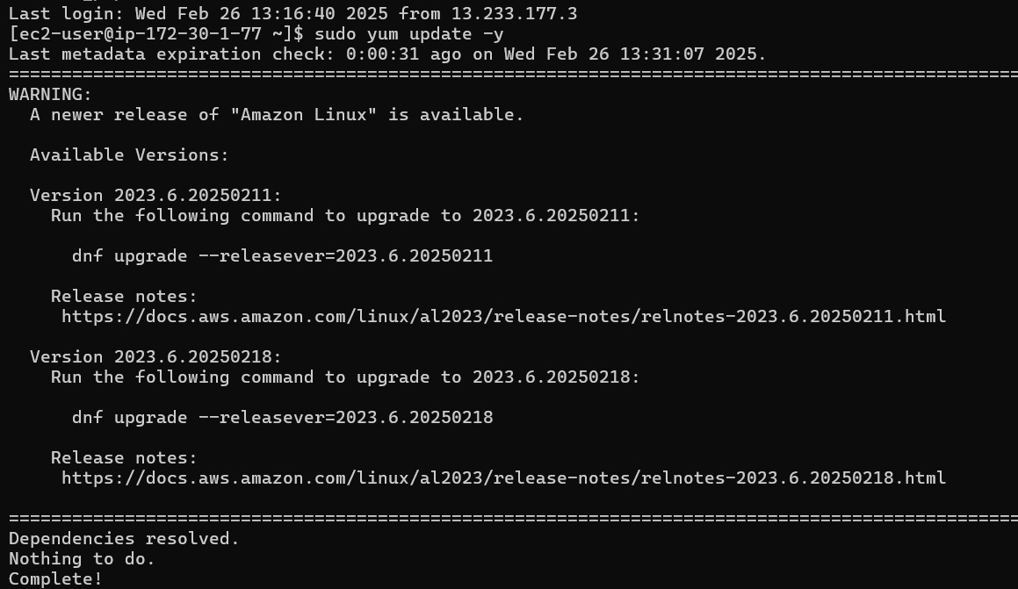

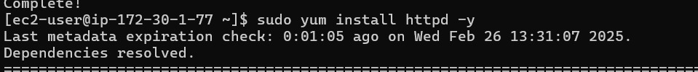







**4. Run webserver2**

Repeat these steps for WebServer2 but change the message in the last command to:

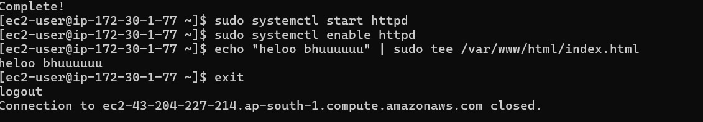

**4. Create a Target Group**

In the AWS Management Console, go to the EC2 Dashboard. Scroll down and click on Target Groups under "Load Balancing." Click Create Target Group.

To create a target group, select Instances as the target type, name it, set the Protocol to HTTP and Port to 80, and choose the same VPC as your EC2 instances (usually the default VPC). Keep the Health Check Path as / to verify the web server's status. Click Next, select both WebServer1 and WebServer2 under "Register Targets," click Include as pending below, and then create the target group.

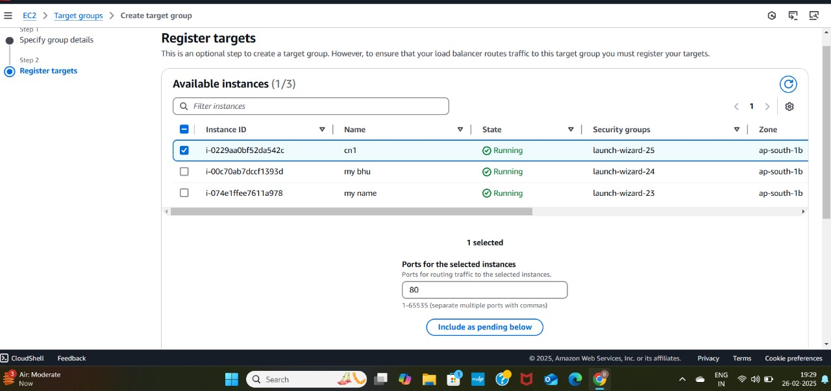

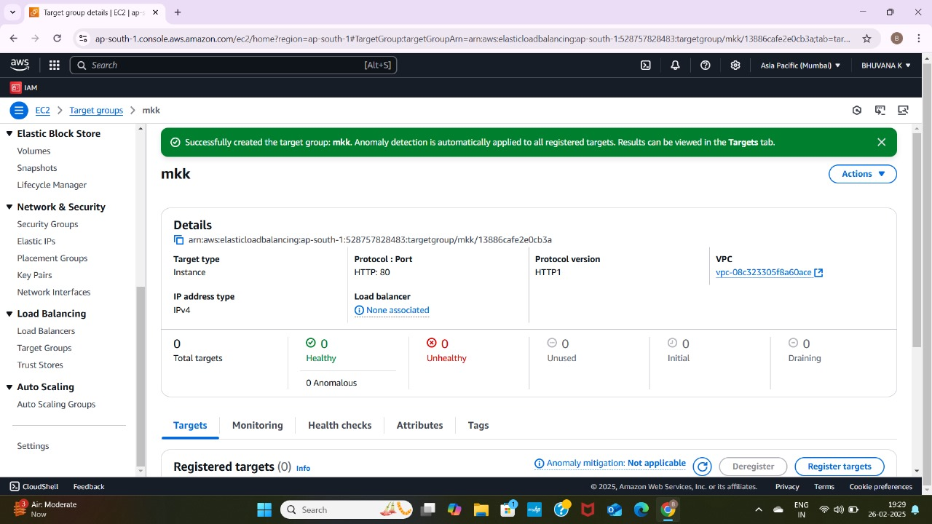

**5. Simulate High CPU Usage**

In the EC2 Dashboard, go to Load Balancers under "Load Balancing" and click Create Load Balancer. Select Application Load Balancer (free tier eligible) and configure it: name it (e.g., "MyALB"), set the Scheme to Internet-facing, IP Address Type to IPv4, and ensure the listener is HTTP on port 80. Select the VPC and at least two subnets for high availability. Skip the security settings since this is HTTP. On the Security Groups page, choose or create a security group that allows HTTP traffic. On the Routing page, select the previously created target group and click Create Load Balancer.

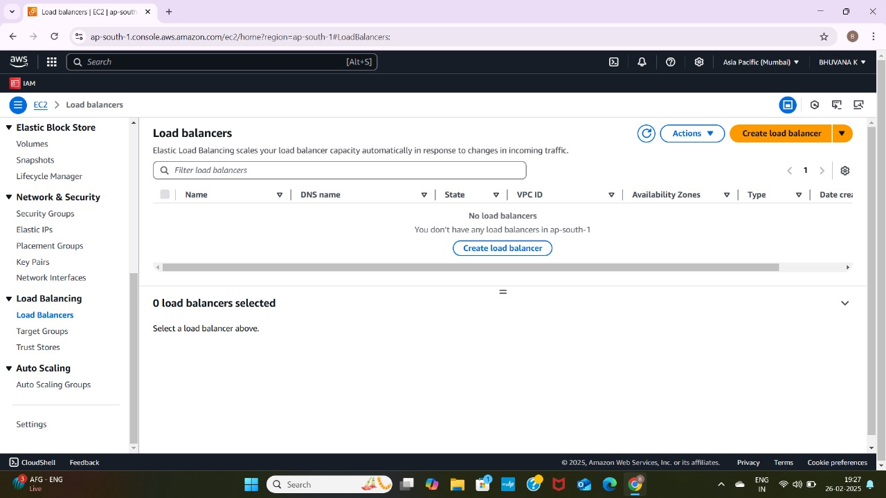

**6. Monitor Scaling Events**

To verify the functionality of your Load Balancer:

1. Go to the Load Balancers section in the AWS Management Console.

2. Select your Load Balancer and find its DNS name under the Description tab.

3. Copy the DNS name and open it in your browser.

4. Refresh the page to confirm that traffic is being alternated between the two EC2 instances. You should see the messages "Hello from WebServer1!" and "Hello from WebServer2!" displayed alternately. This confirms that the Load Balancer is correctly distributing traffic and ensuring high availability.

**Outcome:**

* Launch and configure two EC2 instances with Amazon Linux 2, each hosting a simple web server with unique content.
* Create and configure an Application Load Balancer to distribute incoming traffic between the two EC2 instances.
* Verify the functionality of the Load Balancer by accessing the DNS name and observing traffic alternation between the two web serverr.